Exp 1
Write a python program to implement Simple Calculator program
Aim:
To write a Python program to implement a simple calculator that performs addition, subtraction, multiplication, and division.
Procedure:
- Start the program.
- Get two numbers from the user.
- Display the four arithmetic operations.
- Get the user's choice.
- Perform the selected operation using conditional statements.
- Display the result.
- Stop the program.
Program:
def add(x, y):
return x + y
def subtract(x, y):
return x - y
def multiply(x, y):
return x * y
def divide(x, y):
return x / y
print("Select operation.")
print("1.Add")
print("2.Subtract")
print("3.Multiply")
print("4.Divide")
choice = input("Enter choice(1/2/3/4): ")
num1 = float(input("Enter first number: "))
num2 = float(input("Enter second number: "))
if choice == '1':
print(num1,"+",num2,"=", add(num1,num2))
elif choice == '2':
print(num1,"-",num2,"=", subtract(num1,num2))
elif choice == '3':
print(num1,"*",num2,"=", multiply(num1,num2))
elif choice == '4':
print(num1,"/",num2,"=", divide(num1,num2))
else:
print("Invalid input")
OutPut:
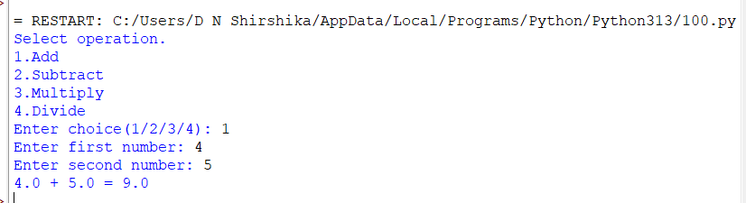

Result:
Hence, the simple python program for multiplication tabl is done

Exp 2: Write a python program to Add Two Matrices
Aim:
To write a python program to add two matrices.
Algorithm:
Step1 : Start by initializing two matrices, matrix A and matrix B, of the same
size (m x n).
Step 2: Initialize an empty matrix, matrix C, also of size m x n.
Step 3: Use a nested loop to iterate over each element in matrix A and matrix B:
Step 4:Add the corresponding elements of matrix A and matrix B and store the
result in the corresponding element of matrix C.
Step 5:Display the resulting matrix C.
Program:
matrix1 = [[1, 2, 3],
[4, 5, 6],
[7, 8, 9]]
matrix2 = [[10, 11, 12],
[13, 14, 15],
[16, 17, 18]]
result = [[0, 0, 0],
[0, 0, 0],
[0, 0, 0]]
for i in range(len(matrix1)):
for j in range(len(matrix1[0])):
# Add corresponding elements of matrices
result[i][j] = matrix1[i][j] + matrix2[i][j]
for row in result:
print(row)

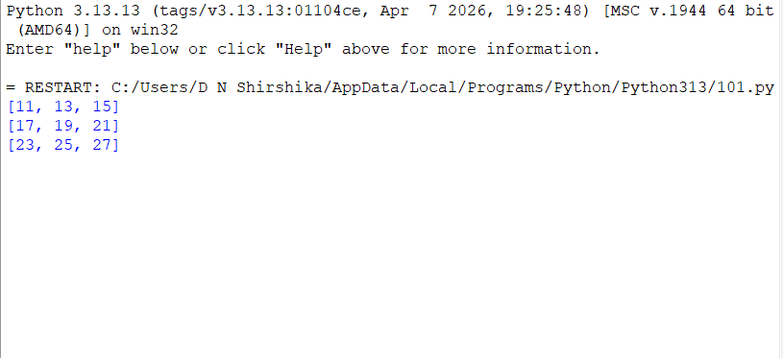

Result:
Thus, the Python program to perform matrix addition was executed successfully.

Exp 3: Write a python program to Transpose a Matrix.
Aim:
To write a python program to transpose a matrix.
Algorithm:
Step 1:Start by initializing the original matrix, matrix A, of size m x n.
Step 2:Initialize an empty matrix, matrix B, of size n x m.
Step 3:Use a nested loop to iterate over each element in matrix A:
Step 4: Store the value of the current element in matrix A in the corresponding
element in matrix B, but with the row and column indices swapped.
Step 5: Display the resulting matrix B.
Program:
matrix = [[1, 2, 3],
[4, 5, 6],
[7, 8, 9]]
rows = len(matrix)
cols = len(matrix[0])
transpose_matrix = [[0 for x in range(rows)] for y in range(cols)]
for i in range(rows):
for j in range(cols):
transpose_matrix[j][i] = matrix[i][j]
print("Original Matrix:")
for row in matrix:
print(row)
print("Transposed Matrix:")
for row in transpose_matrix:

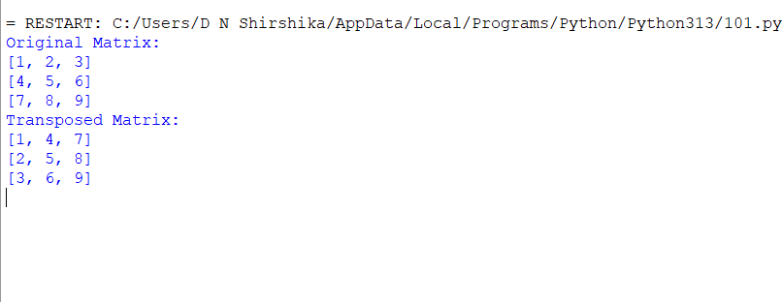

Result: Hence, the simple python program for transpose a matrix is done

Exp 4: Write a python program to sort the sentence in alphabetical order
Aim:
To write a python program to sort the sentence in alphabetical order.
Algorithm:
Step 1: Start by taking input of the sentence.
Step 2: Split the sentence into individual words and store them in a list.
Step 3: Use the sort() method to sort the list of words in alphabetical order.
Step 4: Join the sorted list of words back into a sentence.
Step 5: Display the resulting sorted sentence.

Program:
sentence = input("Enter a sentence: ")
words = sorted(sentence.split())
sorted_sentence = " ".join(words)
print("Sorted sentence:", sorted_sentence)

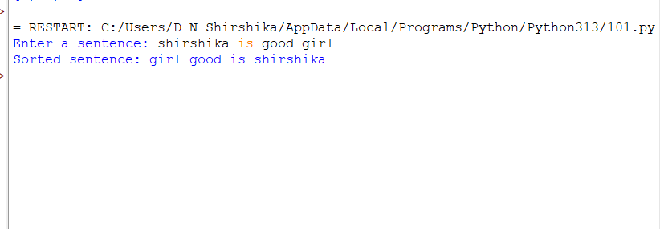

Result: Hence, the simple python program for sort the sentence in alphabetical order is done

Exp 5: Write a python program to implement List operations (Nested List, Length, Concatenation,Membership, Iteration, Indexing and Slicing)

Aim:
To write a python program to implement the given list operations.
Algorithm:
Step 1: Start by initializing a list.
Step 2: Use the len() function to find the length of the list.
Step 3: Use concatenation to join two lists.
Step 4: Use the in keyword to check if an element is in the list.
Step 5: Use a for loop to iterate over the list.
Step 6: Use indexing to access a specific element in the list.
Step 7: Use slicing to access a range of elements in the list.
Program:
nested_list = [[1, 2, 3], [4, 5, 6], [7, 8, 9]]
print("Nested List:", nested_list)
my_list = [1, 2, 3, 4, 5]
print("Length of List:", len(my_list))
list1 = [1, 2, 3]
list2 = [4, 5, 6]
concatenated_list = list1 + list2
print("Concatenated List:", concatenated_list)
my_list = [1, 2, 3, 4, 5]
if 3 in my_list:
print("3 is in the list")
else:
print("3 is not in the list")

my_list = [1, 2, 3, 4, 5]
for item in my_list:
print(item)
my_list = [1, 2, 3, 4, 5]
print("First element:", my_list[0])
print("Last element:", my_list[-1])
print("Sliced List:", my_list[1:4])

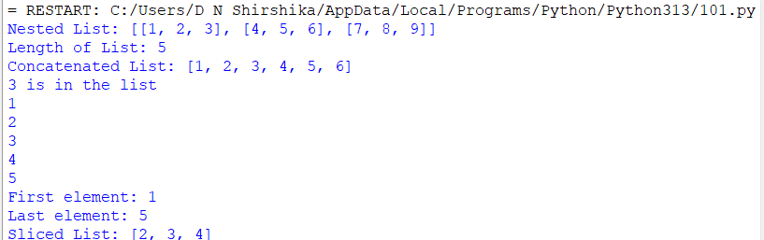

Result:
Hence, the simple python program for implement the operations is done

Exp 6: Write a python program to implement List methods (Add, Append, Extend & Delete).
Aim:
To write a python program to implement the given list methods.
Algorithm:
Step 1: Start by initializing a list.
Step2: Use the append() method to add an element to the end of the list.
Step3: Use the extend() method to add multiple elements to the end of the list.
Step4: Use the insert() method to add an element at a specific index in the list.
Step5: Use the remove() method to remove a specific element from the list.
Step6: Use the pop() method to remove and return the last element of the list, or a
specific element by index.
Step 7: Use the del keyword to delete an element or slice from the list.
Program:
my_list = []
my_list.add(1)
print("List after adding an item using add method:", my_list)
my_list.append(2)
print("List after appending an item using append method:", my_list)
my_list.extend([3, 4, 5])
print("List after extending using extend method:", my_list)
my_list.remove(3)
print("List after removing an item using remove method:", my_list)

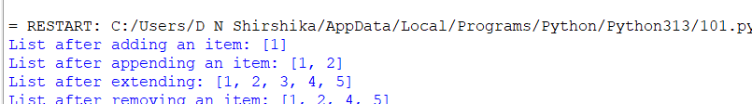

Result: Thus, the Python program to demonstrate list methods such as append(), extend(), and remove() was executed successfully.

Exp7: Write a Python Program to Illustrate Different Set Operations
Aim:
To write a python program to illustrate different set operations.
Algorithm:
Step1: Create two sets setA and setB containing some elements.
Step2: Perform the intersection operation on the sets by using the intersection()
method and store the result in a new set intersection_set.
Step3: Perform the union operation on the sets by using the union() method and store
the result in a new set union_set.
Step4: Perform the difference operation on the sets by using the difference() method
and store the result in a new set difference_set.
Step5: Check if setA is a subset of setB by using the issubset() method and print the
result.
Program:
set1 = {1, 2, 3, 4, 5}
set2 = {4, 5, 6, 7, 8}
print("Set 1:", set1)
print("Set 2:", set2)
print("Intersection of set1 and set2:", intersection_set)
union_set = set1.union(set2)
print("Union of set1 and set2:", union_set)
difference_set = set1.difference(set2)
print("Difference between set1 and set2:", difference_set)
symmetric_difference_set = set1.symmetric_difference(set2)
print("Symmetric difference between set1 and set2:", symmetric_difference_set)
subset_check = set1.issubset(set2)
print("Set 1 is subset of set 2:", subset_check)

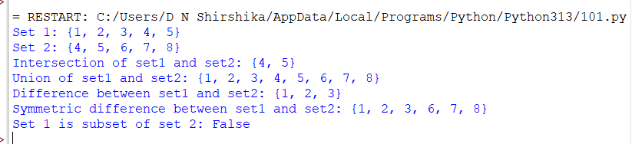

Result: Thus, the Python program to perform set operations such as intersection, union, difference, symmetric difference, and subset checking was executed successfully.

Exp 8: Write a python program to generate Calendar for the given month and year
Aim:
To write a python program to generate calendar for the given month and year.
Algorithm:
Step1: Take the input month and year from the user.
Step2: Calculate the total number of days in the given month using a formula that
takes into account whether it's a leap year or not.
Step3: Determine the day of the week for the first day of the given month using
Zeller's congruence formula or any other method to calculate day of the week.
Step4: Print the header for the calendar.
Step5: Print the days of the week as column headers.
Step6: Print the resulting calendar.
Program:
import calendar
year = int(input("Enter the year: "))
month = int(input("Enter the month: "))
print(calendar.month(year, month))

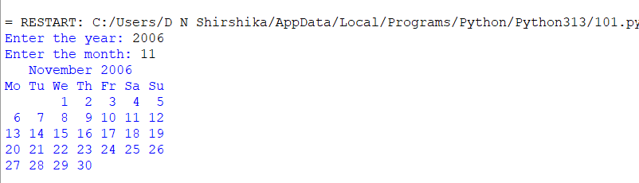

Result:
Thus, the Python program to display the calendar for a given month and year was executed successfully.

Exp: 9 Write a Python Program to Remove punctuations from the given String
Aim:
To write a python program to remove punctuations from the given string.
Procedure:
- Import the string module.
- Get a string from the user.
- Use string.punctuation to identify punctuation marks.
- Remove punctuation marks using translate() and maketrans().
- Display the string without punctuation marks.

Program:
import string
input_string = input("Enter a string: ")
no_punctuations = input_string.translate(str.maketrans("", "", string.punctuation))
print("String with no punctuations:", no_punctuations)

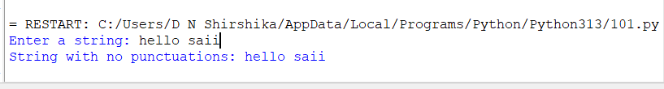

Result:
Thus, the Python program to remove punctuation marks from the given string was executed successfully.

Exp :10 Write the Python Program to solve 8-Puzzle Problem.
Aim:
To write a python program to solve the 8-puzzle problem.
Algorithm:
Step1: Dequeue the state with the lowest priority from the frontier.
Step2: If the dequeued state is the goal state, return the solution path.
Step3: Add the dequeued state to the explored set.
Step4: Generate all possible successor states by swapping the empty tile with its
neighboring tiles.
Step5: For each successor state, calculate its priority based on the Manhattan distance
and add it to the frontier if it has not been explored before.
Program:

from queue import PriorityQueue

goal_state = (1, 2, 3, 4, 5, 6, 7, 8, 0)

def heuristic(state):
distance = 0
for i in range(3):
for j in range(3):
tile = state[i * 3 + j]
if tile != 0:
x = (tile - 1) // 3
y = (tile - 1) % 3
distance += abs(x - i) + abs(y - j)
return distance

def solve(initial_state):
frontier = PriorityQueue()
frontier.put((heuristic(initial_state), 0, initial_state, []))
explored = set()
counter = 1

while not frontier.empty():
_, cost, state, path = frontier.get()

if state in explored:
continue

explored.add(state)
path = path + [state]

if state == goal_state:
return path

zero = state.index(0)
row, col = zero // 3, zero % 3

for dr, dc in [(0, 1), (0, -1), (1, 0), (-1, 0)]:
nr, nc = row + dr, col + dc

if 0 <= nr < 3 and 0 <= nc < 3:
new_zero = nr * 3 + nc
new_state = list(state)
new_state[zero], new_state[new_zero] = (
new_state[new_zero], new_state[zero]
)
new_state = tuple(new_state)

if new_state not in explored:
frontier.put((
cost + 1 + heuristic(new_state),
cost + 1,
new_state,
path
))
counter += 1

return None

initial_state = tuple(map(int, input("Enter 9 numbers (use 0 for blank): ").split()))

if len(initial_state) != 9 or set(initial_state) != set(range(9)):
print("Invalid input")
else:
solution = solve(initial_state)

if solution:
print("Solution found in", len(solution) - 1, "moves:")
for state in solution:
for i in range(0, 9, 3):
print(state[i:i + 3])
print()
else:
print("No solution exists")
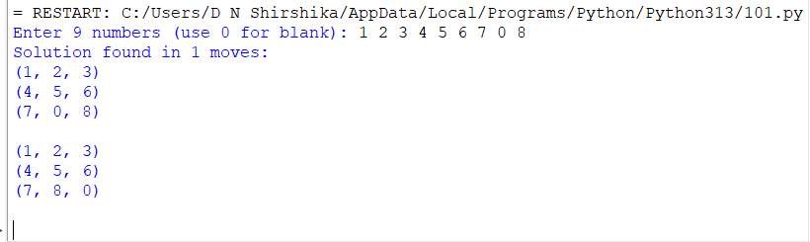

Result:
Thus, the Python program to solve the 8-puzzle problem using the A* search algorithm and Manhattan distance heuristic was executed successfully.

